LLM AI Agent Module Documentation

1. Introduction
The LLM AI Agent Module serves as an intelligent interface between users and the Alsonotify backend. It leverages Large Language Models (LLMs) to understand natural language queries, map them to internal API endpoints, execute requests, and summarize the results in a user-friendly format.

1.1 Key Features
- Natural Language Understanding: Converts vague user requests (e.g., “Show me my tasks”) into precise API calls.
- Dynamic Endpoint Discovery: Automatically discovers available “allowed” endpoints from the system’s Swagger/OpenAPI documentation.
- Context Awareness: Identifies the authenticated user to perform context-specific queries (e.g., “assigned to me”).
- Intelligent Summarization: Formats raw JSON API responses into clean, readable Markdown summaries.
- Security & Guardrails: Includes strict sanitization of inputs and outputs to prevent data leaks and “out-of-scope” hallucinations.

2. Architecture & Workflow
The agent operates as a multi-step pipeline triggered by a single endpoint.

2.1 High-Level Workflow
- Request: Client sends a prompt to /api/generate.
- Scope Check: The agent analyzes the prompt to determine if it is relevant to business data (Tasks, Projects, Leaves, etc.). If “Out of Scope”, it rejects the query.
- Tool Selection: If in scope, the LLM selects the most appropriate internal API endpoint (Tool) and extracts parameters (e.g., dates, status) from the text.
- Execution: The agent makes an internal HTTP request to the selected endpoint using the user’s authentication context.
- Summarization: The raw data returned by the API is sanitized (sensitive IDs removed) and fed back to the LLM to generate a Markdown response.
- Response: The final Markdown summary is sent back to the client.

2.2 Component Diagram
Alsonotify AI Agent Component Diagram

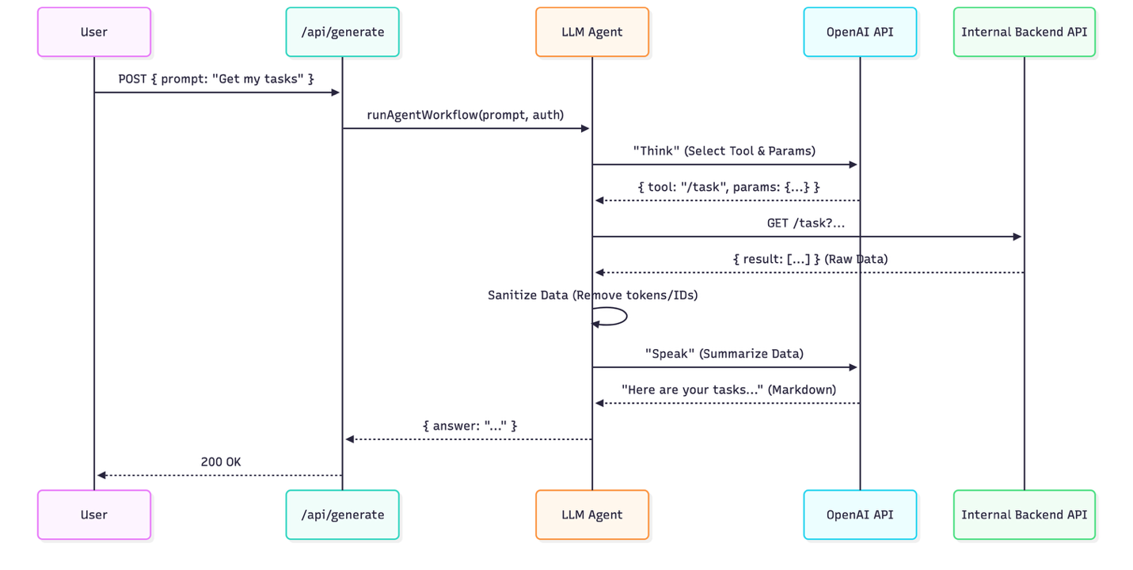

3. Setup & Configuration

3.1 Environment Variables
The module requires the following configuration in your .env file:
- OPENAI_API_KEY: A valid API key for OpenAI.
- OPENAI_MODEL: (Optional) The model to use, default is gpt-4o.

3.2 Initialization
The agent initializes automatically when the server starts. It fetches the Swagger JSON documentation from the local server to learn available endpoints.
- Location: index.ts calls initializeLLMAgent(baseUrl).
- Startup Log: You should see ✅ LLM Agent initialized successfully in the console.

4. Core Components

4.1 Utils (utils/llm-agent.ts)
This file contains the core logic for the agent.
- runAgentWorkflow: The main entry point orchestrating the Flow.
- queryLLM: Sends the “Think” prompt to OpenAI to decide which endpoint to call.
- executeTool: Handles parameter substitution (path params vs query params) and executes the internal API call using axios.
- formatResponse: Sends the “Speak” prompt to OpenAI to summarize the data.
- sanitizeApiData: Recursively strips sensitive fields (like passwords, tokens, _id) from API responses before they reach the LLM.

4.2 Routes (routes/llm-routes.ts)
Exposes the public interface for the agent.
- Endpoint: POST /api/generate
- Body: { "prompt": "string" }
- Headers: Requires standard Authorization header to identify the user.

4.3 Swagger Integration
The agent does not have hardcoded endpoints. It dynamically reads the api-docs/json provided by Fastify Swagger.
- Filtering: Only endpoints tagged with "allowed" in their Swagger definition are visible to the agent.

5. Capabilities & Logic

5.1 Scope Detection
The system prompt explicitly defines what is “In Scope” (Tasks, Leaves, Reports, etc.) and “Out of Scope” (General knowledge, coding questions).
- Logic: If the LLM returns "out_of_scope": true, the agent returns a pre-canned graceful refusal without hitting any internal APIs.

5.2 Context Awareness (“My” Data)
When the user says “My tasks” or “My leaves”, the agent aims to filter by the current logged-in user.
- Mechanism: The agent extracts the User ID from the JWT token passed in the Authorization header.
- Prompt Injection: This User ID is injected into the system prompt (“Current User ID: 123”), allowing the LLM to map “my” to member_id=123.

5.3 Client-Side Logic
- Start Date Filtering: Since some backend endpoints might not support complex nested date objects passed by the LLM, the agent performs a secondary pass of date filtering in memory (client-side date filtering) to ensure accuracy.
- ID Stripping: The final response string is regex-scrubbed to ensure no internal database IDs (like user_id: 55) leak to the user, even if the LLM tries to include them.

6. API Specification

6.1 Generate Response
Endpoint: POST /api/generate
Request Body:
{
"prompt": "Show me pending leave requests"
}
Response (Success):
{
"answer": "### Pending Leave Requests\n\n| Type | Date | Status |\n|---|---|---|\n| Sick Leave | Dec 12, 2024 | **Pending** |"
}
Response (Error):
{
"error": "Failed to process LLM request."
}

7. Security & Guardrails
Guardrail | Description
Input Sanitization | User queries are stripped of potentially malicious characters and URL links.
Data Redaction | All API responses are deep-cleaned to remove fields like password, token, secret, api_key before being sent to the LLM.
Output Scrubbing | The final Markdown text is scanned to remove inadvertent ID leaks (e.g., User ID: 5).
Scope Enforced | The system prompt forces the LLM to reject queries unrelated to business data, preventing “jailbreaks” or general chatbot usage.
Auth Forwarding | The agent performs actions on behalf of the user by forwarding their JWT. It cannot access data the user doesn’t have permission to see.

